SELF REFLECTION

This week’s practical assignment was relatively very easy compared to last week. My experience was very nice. Every part of my code is working and I did not face any issues understanding the concept behind the spirit level app.

After completing this week’s practical, I feel that this practical is very essential for our assignment 1 part 2. Implementation of sensors is an essential part of our assignment and this practical helps us a lot in understanding how we can use sensors in android apps. Therefore, this practical was very important.

After completing this practical, I can evaluate that implementing sensors in an android app is not very difficult. However, it can be confusing to check whether the sensors that we intend to use in the program are accessible or not.

After this week’s practical work, I can analyse that our assignment part 2 is going to be much harder than part 1. This is because sensor implementation makes the app more dynamic and it will be difficult to come up with a good idea in order to implement sensors in a game.

I would like to conclude by saying that I really enjoyed this practical. After last week’s intense practical, this week’s practical was very relieving. Being able to complete it in a short time was very satisfying. However, I look forward to face a more challenging practical next week and use the knowledge I acquired this week to create a great app for my assignment part 2.

Here are some screenshots from this week’s practical:

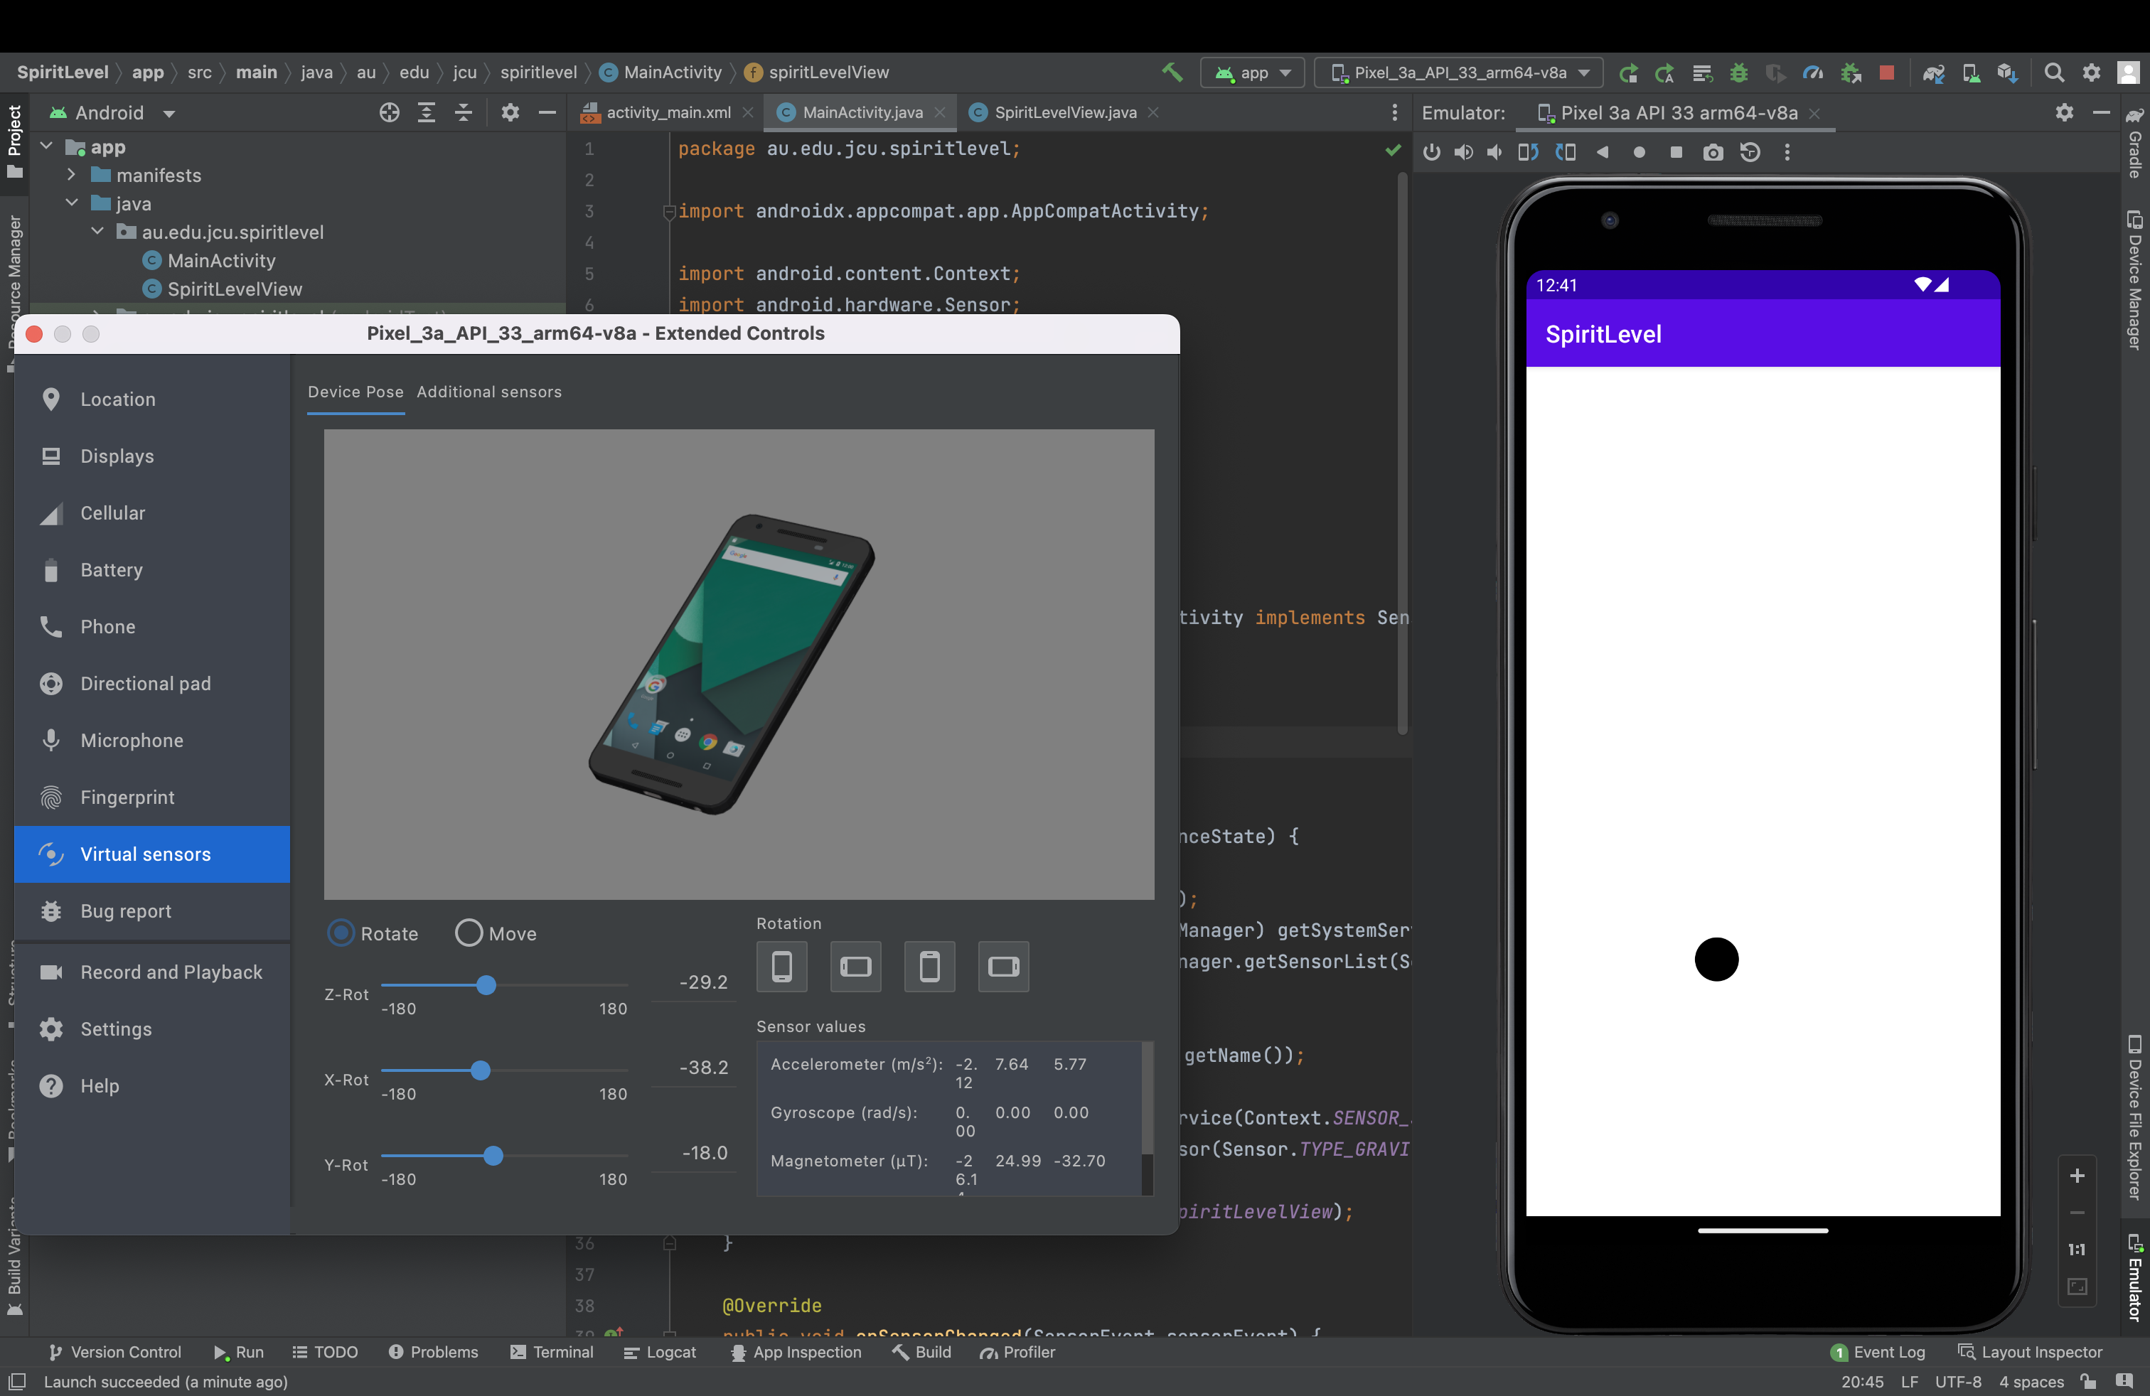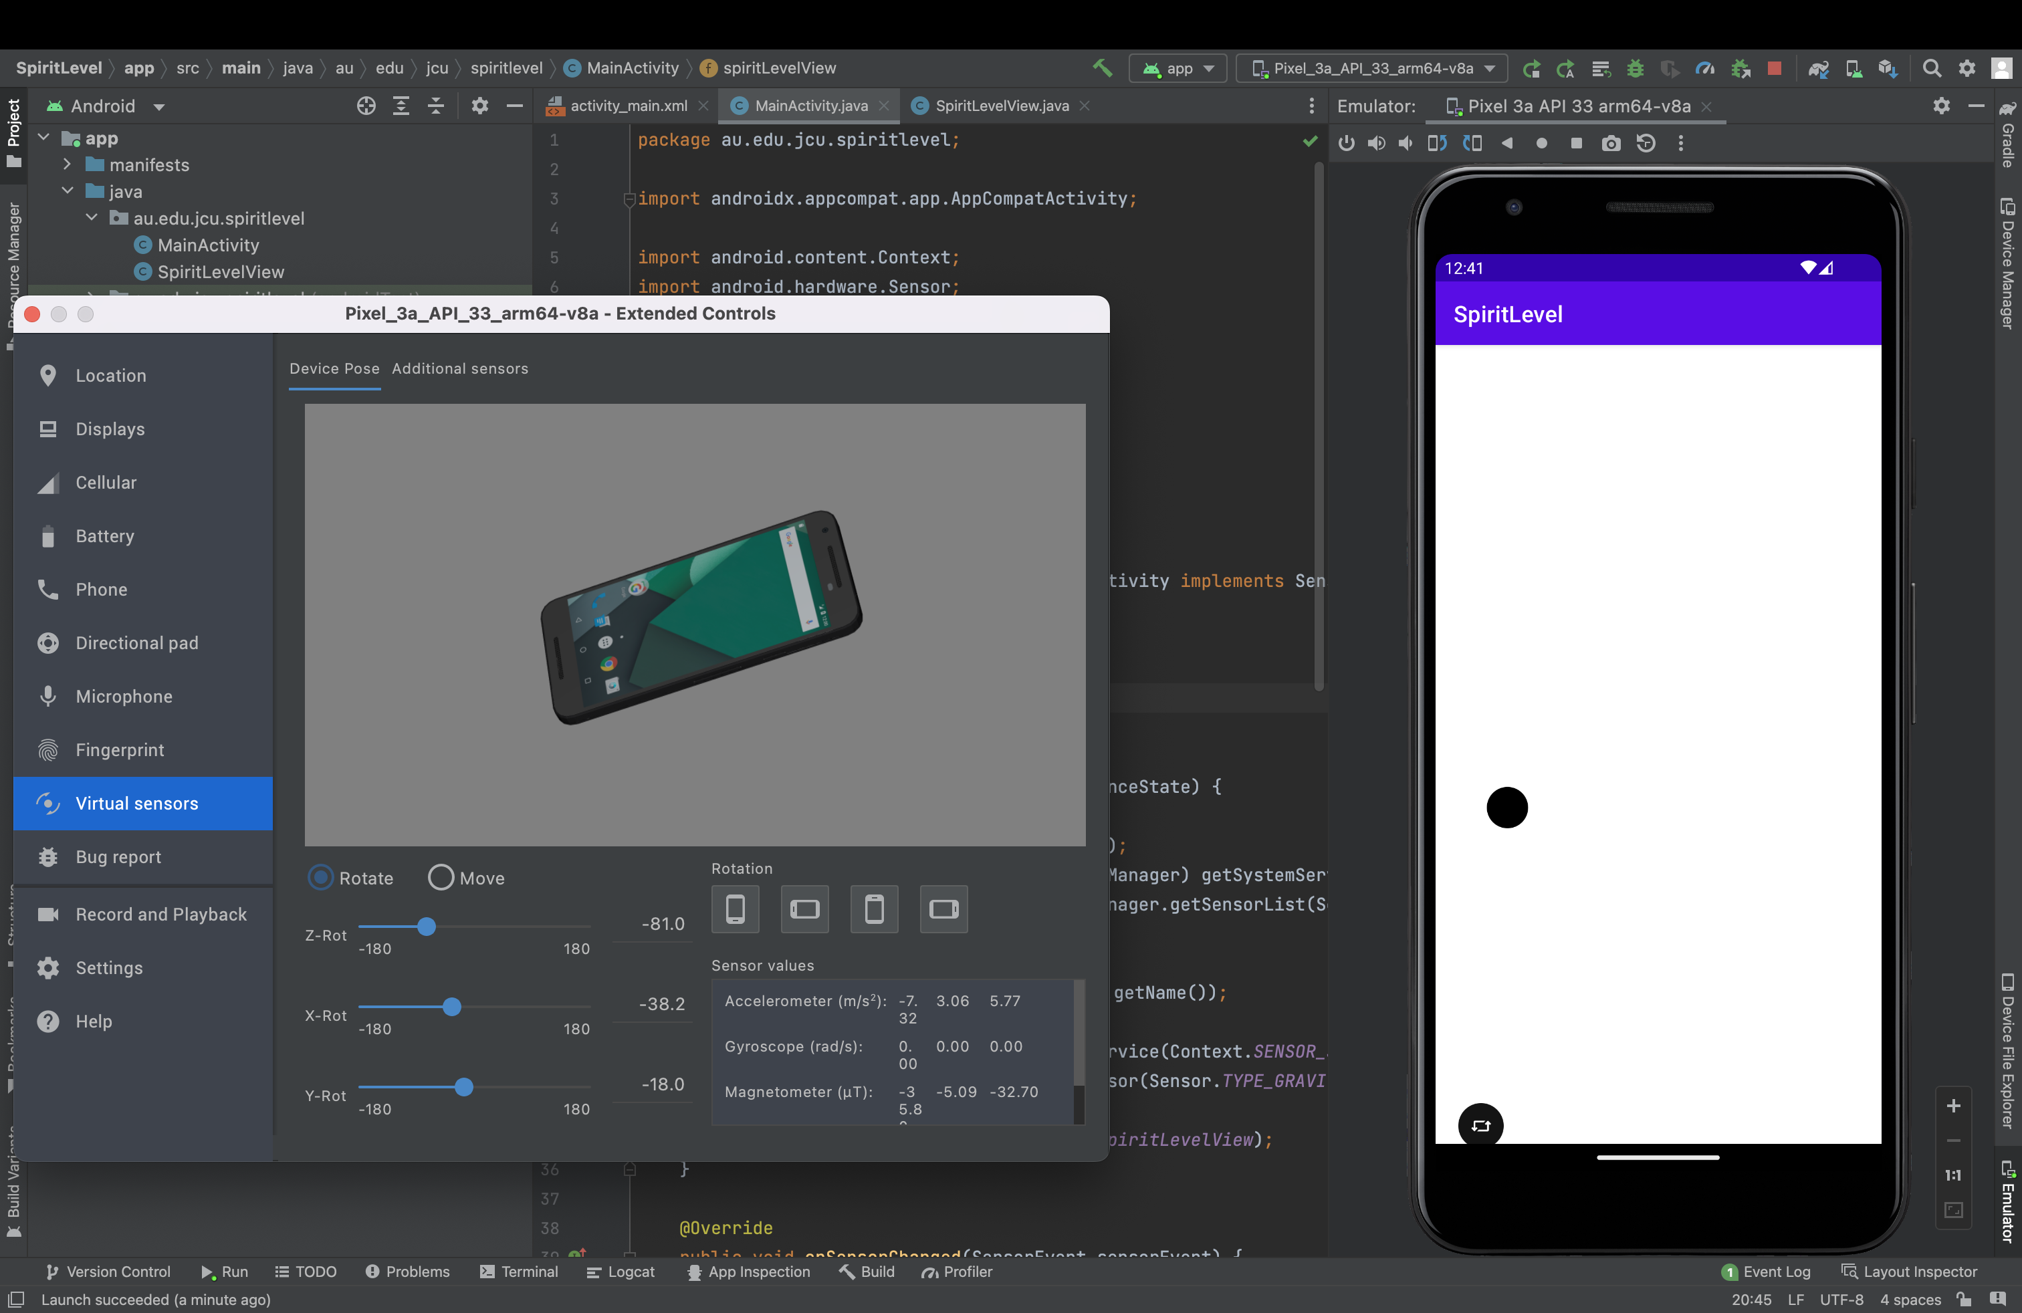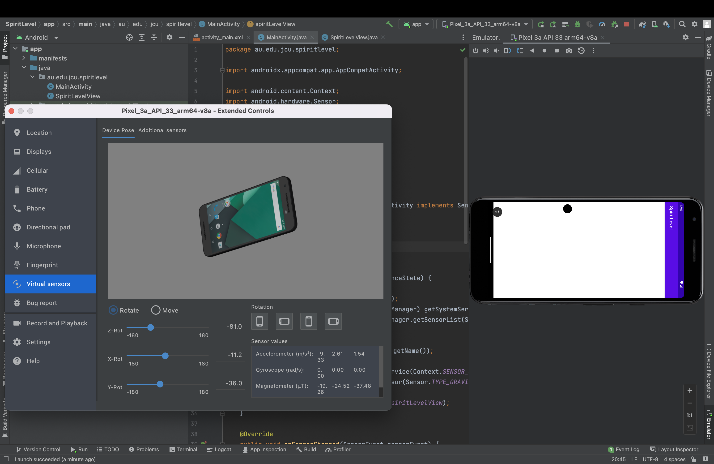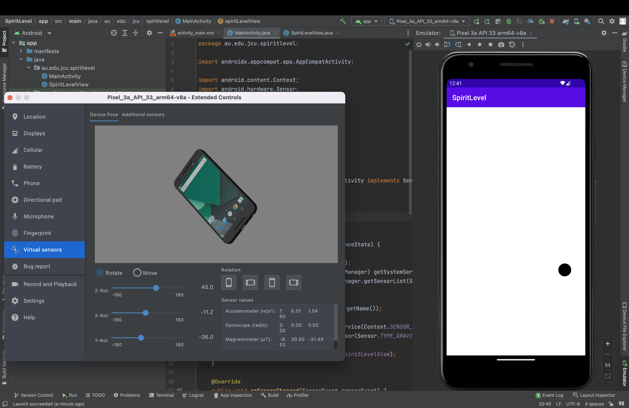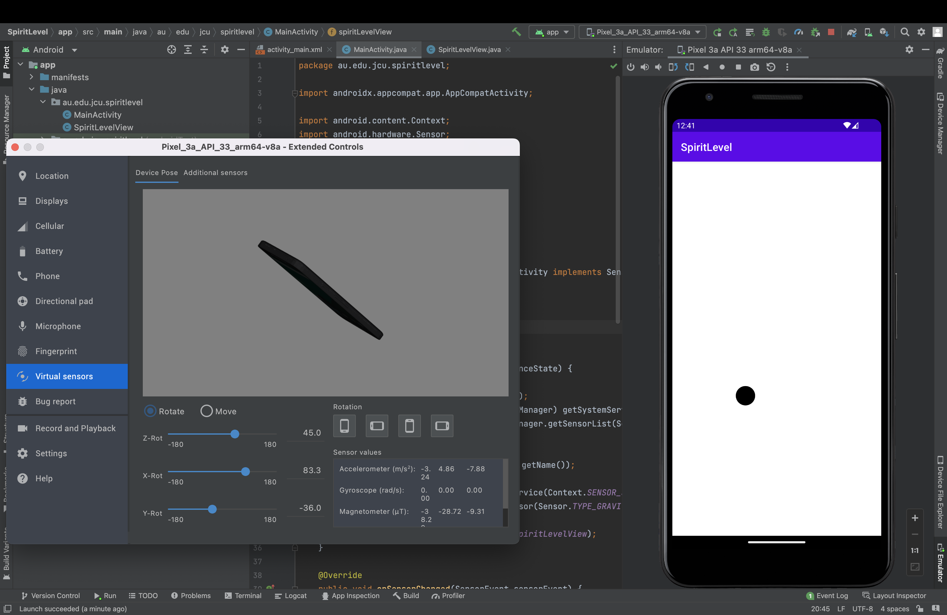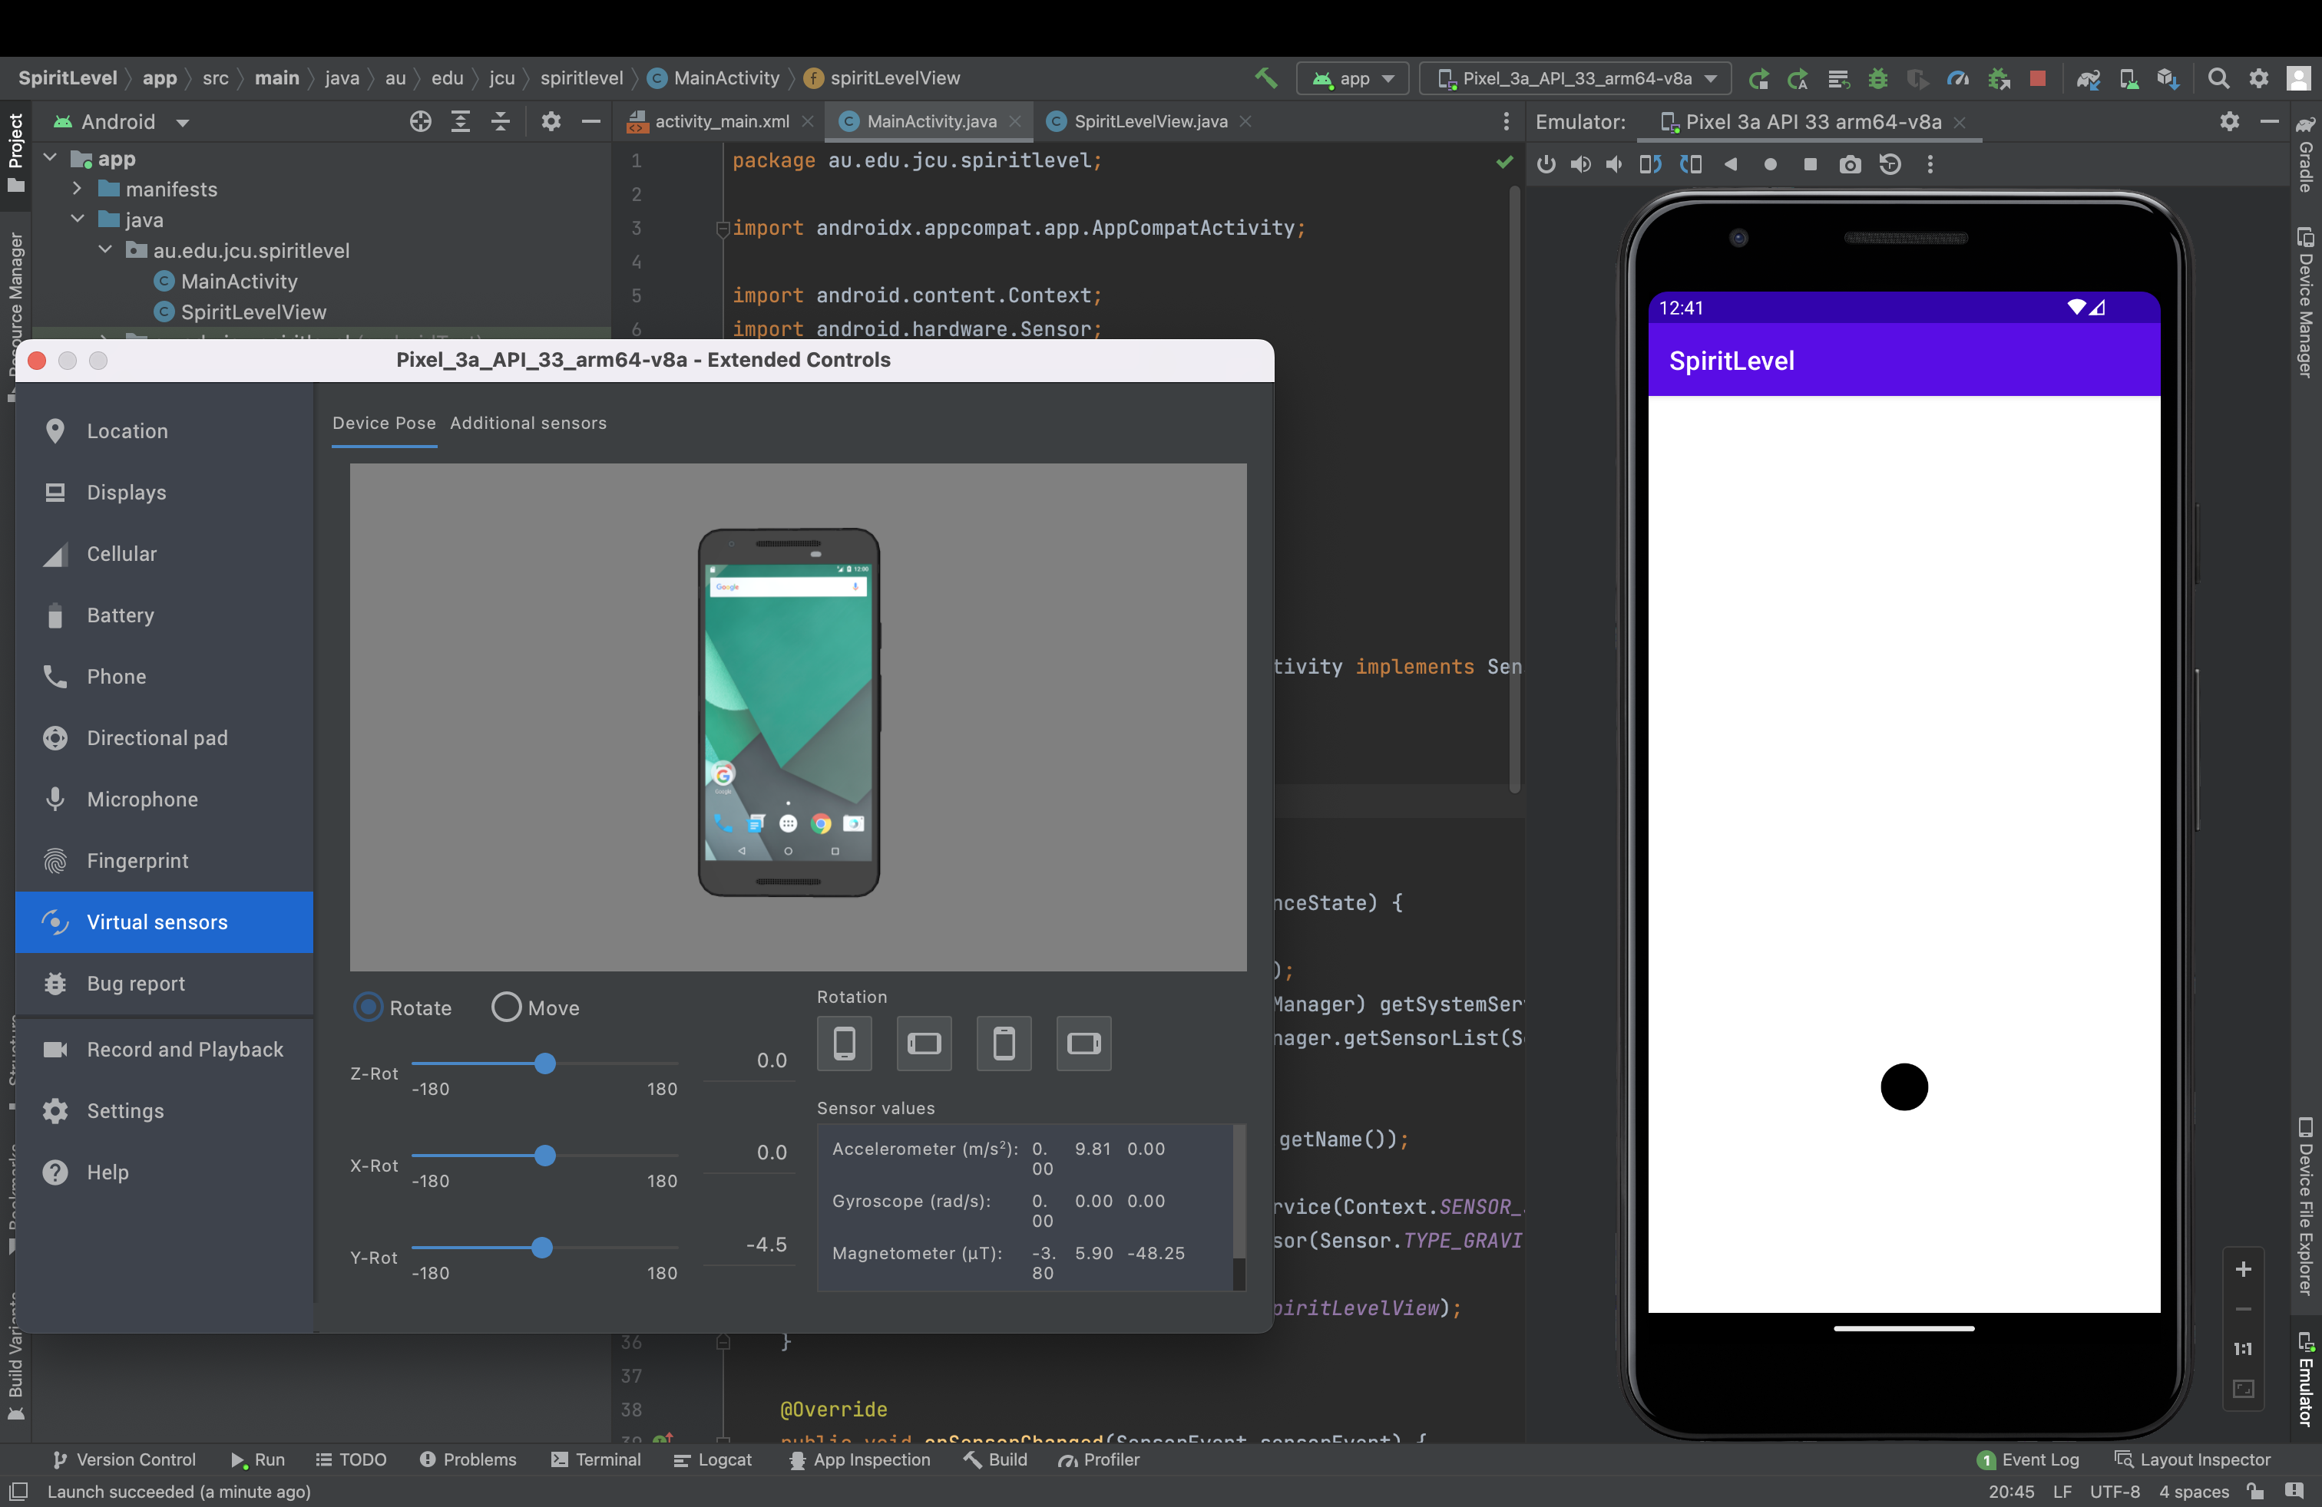

Here are the screenshots from practical 4:

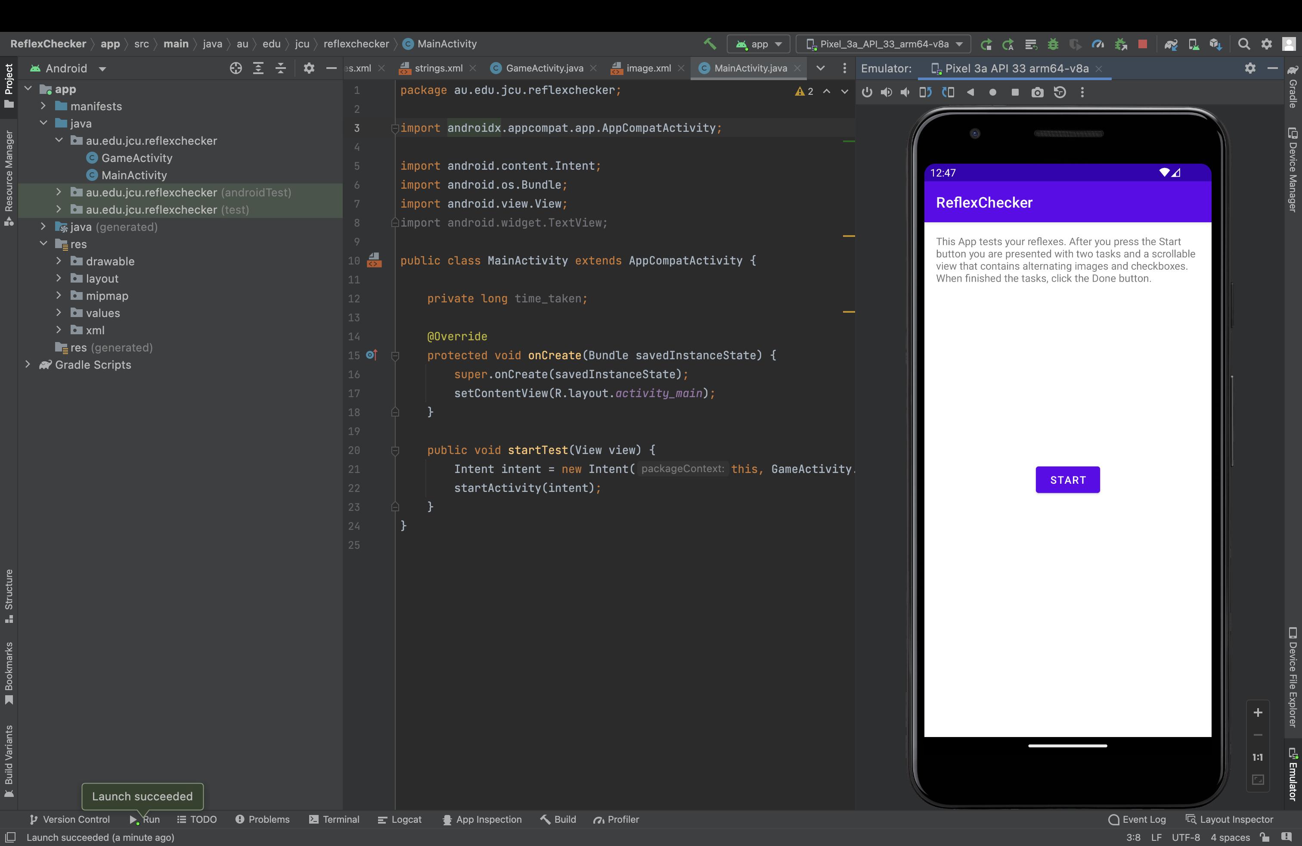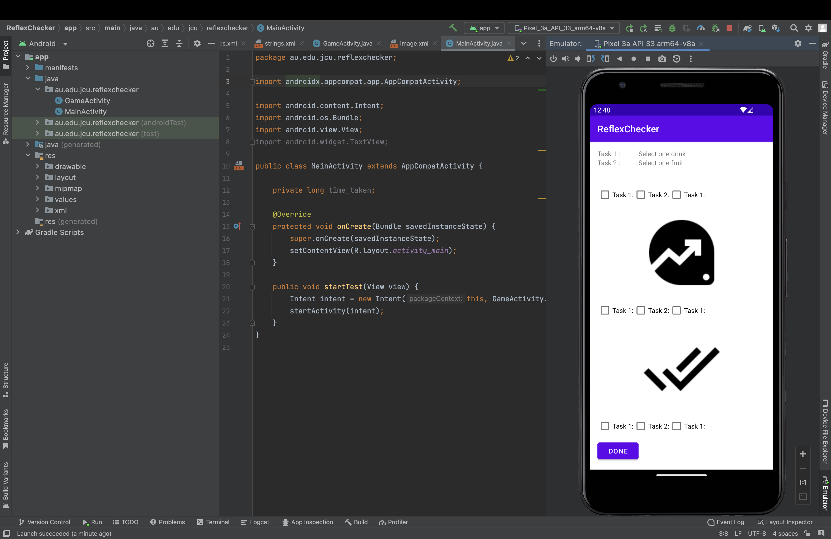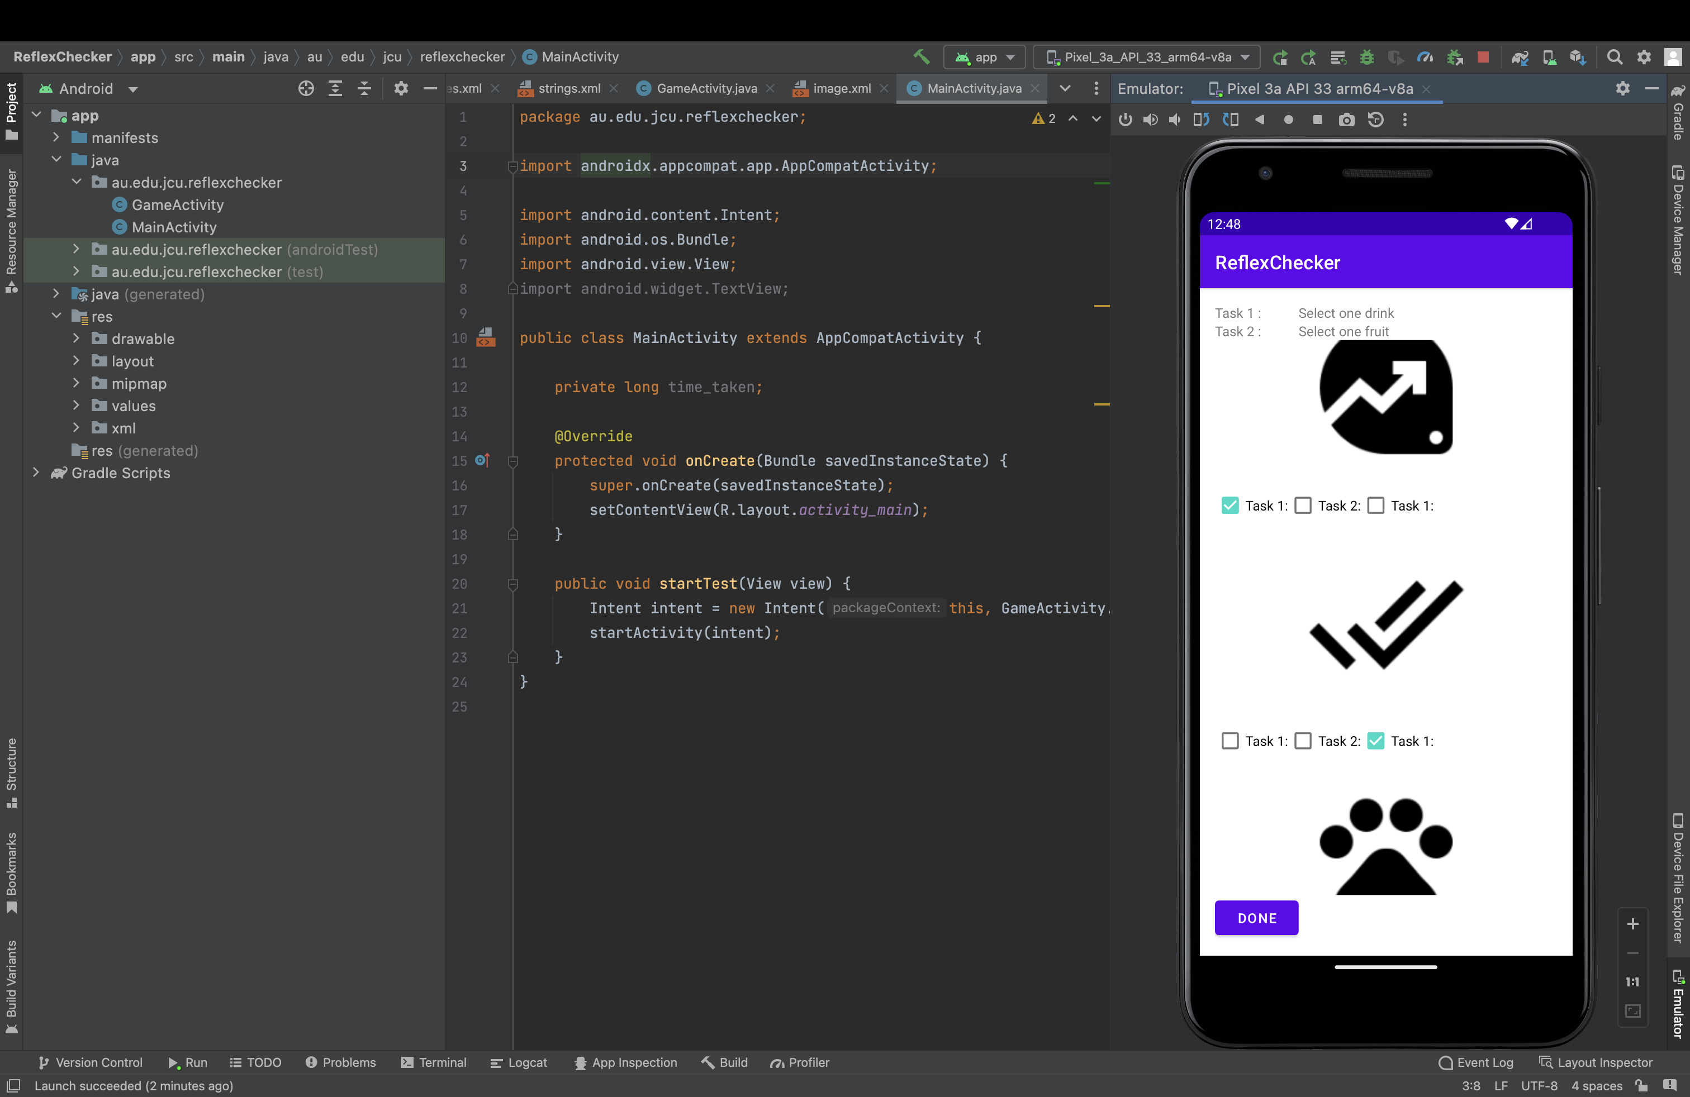

Here are the screenshots from practical 5:

